COMPUTER PROGRAMMING
LAB REPORT 1
Installation of DEV-C++ IDE and Running the First C++ Program

OBJECTIVE
➢ The purpose of this lab is to understand the installation and use of the DEV-C++ Integrated Development Environment (IDE) and to execute a basic C++ program successfully. Students also learn how to upload their work to GitHub for submission and version control.

THEORY
➢ C++ is a high-level programming language widely used in software development and engineering applications. To write and run C++ programs, programmers use an Integrated Development Environment (IDE). DEV-C++ is a beginner-friendly IDE that provides tools such as a code editor, compiler, and output console in one environment. Every C++ program starts from the main() function, which acts as the entry point of execution. The cout statement is used to display output on the screen.

SOFTWARE
- DEV-C++ IDE
- C++ Compiler (included with DEV-C++)
- GitHub Account

PROCEDURE / PROCESS

Step 1: Install DEV-C++
- Download DEV-C++ from its official website.
- Install the software on the computer.
- Launch DEV-C++ after installation.
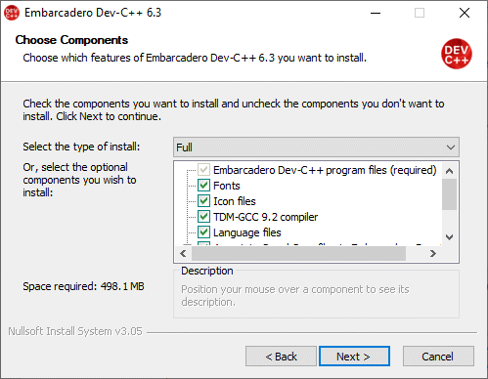

Step 2: Create a New C++ Program
- Click File → New → Source File.
- A new blank editor window will appear.
- Click File → Save As.
- Save the file with the name lab1_hello.cpp.

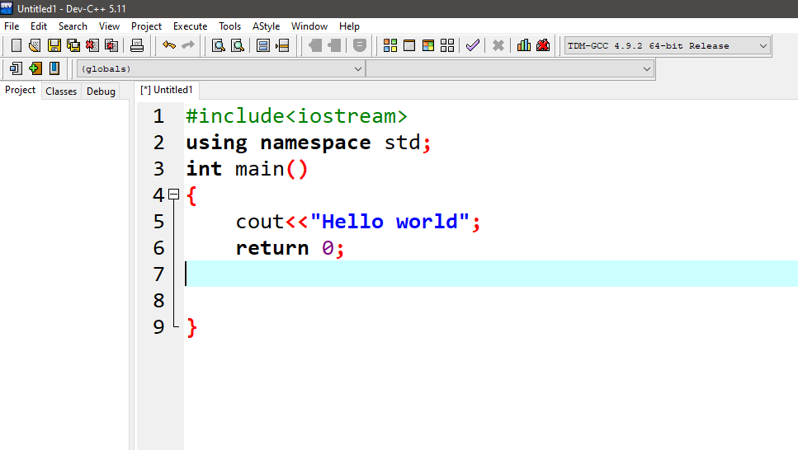

Step 3: Write the First C++ Program
#include <iostream> using namespace std;
int main() { cout << "Hello World!"; return 0;
}

Step 4: Compile and Run the Program
- Click Execute → Compile.
- Then click Execute → Run.
- The output window will display the result of the program.



GITHUB TASK
- Open the official GitHub website: GitHub
- Click on the Sign Up button.
- Enter your email address, username, and password.
- Verify your account and complete the registration process.
- After successful registration, log in to your GitHub account.
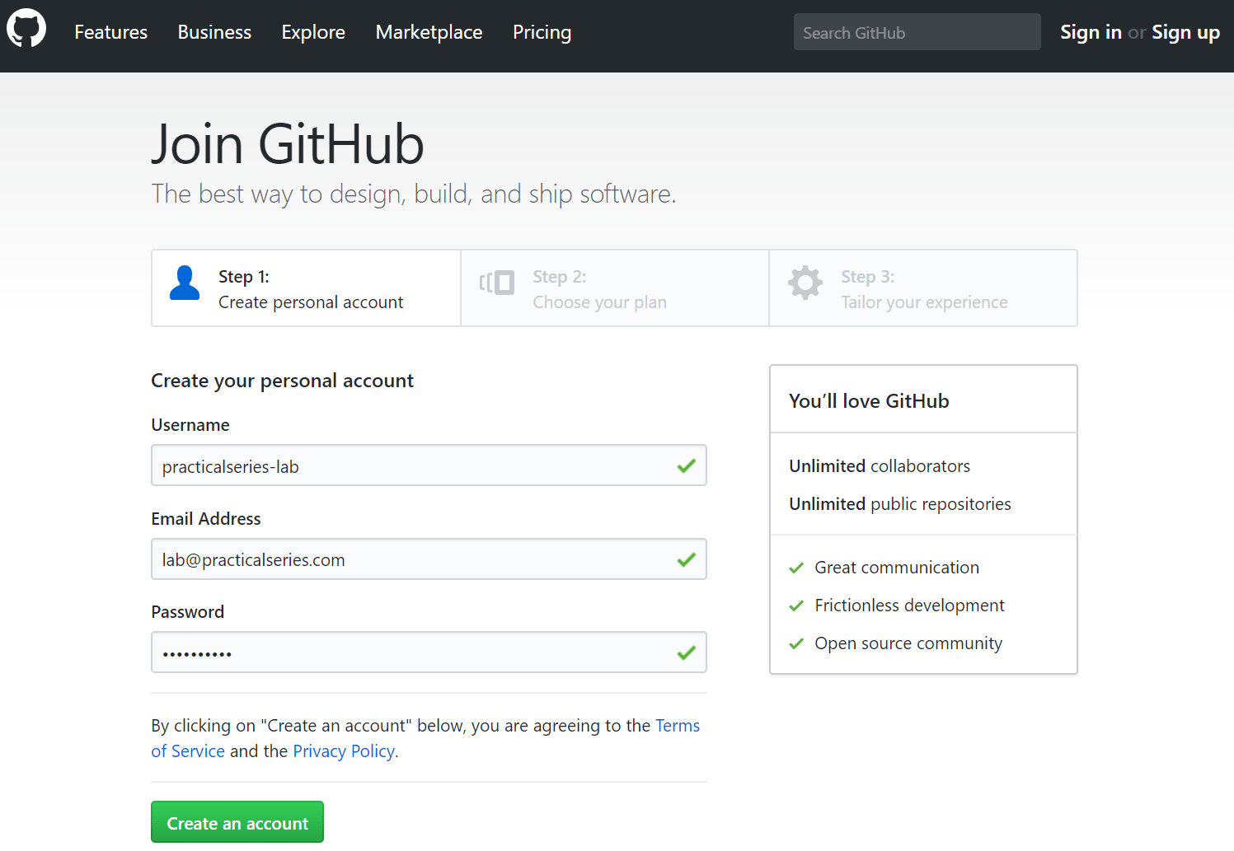

Step 2: Create a Repository Named “Cpp-Lab-Tasks”
- After logging in, click the + icon in the top-right corner.
- Select New repository.
- In the repository name field, type Cpp – lab - Tasks.
- Choose the repository visibility as Public .
- Click the Create Repository button.

Step 3: Upload the File “lab1_hello.cpp”
- Open the created repository Cpp-Lab-Tasks.
- Click on the Add File button.
- Select Upload Files.
- Drag and drop the file lab1_hello.cpp or click Choose Your Files to browse the file from the computer.
- After uploading, click the Commit Changes button.

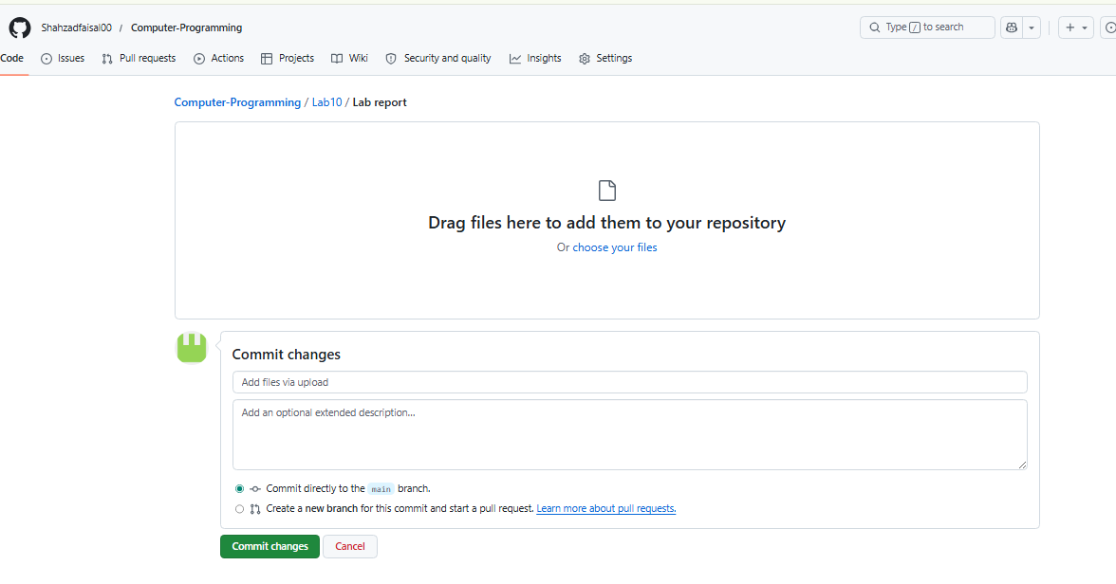

GitHub Repository Link: https://github.com/Shahzadfaisal00/Computer-Programming
➢ The GitHub repository stores the lab files securely online and helps in maintaining backup, version control, and easy sharing of programming tasks.

CONCLUSION
➢ In this lab session, we learned how to install and use the DEV-C++ IDE to create, compile, and run a basic C++ program successfully. We also learned how to use GitHub for uploading and managing programming files. This lab improved our understanding of programming tools and basic software development practices.

